


Don Mariano Marcos State University
South La Union Campus
COLLEGE OF COMPUTER SCIENCE
Agoo, La Union

July 1, 2026

EMELY A. MUNAR, DIT (c)
Faculty Member, College of Computer Science
DMMMSU – SLUC
Agoo, La Union

Sir/Madam:

We, the undersigned BS Computer Science students are enrolled in the subject Thesis Writing. One of the requirements of the course is for us to undergo the process of research and be able to create a project that will beneficial to the university.

In connection to this, we would like to ask for your support to be our Thesis Adviser for our study entitled “Design and Implementation of a Real-Time LAN-Based Queuing Management and Statistical Reporting System for the Business Permits, Licensing - Local Investment and Enterprise Office (BPL-LIEO) of LGU Rosario, La Union”.

We hope that this request will merit your approval. We will highly appreciate your considerations to this regard.

Thank you very much and more power.

Very truly yours,

  TANDAS, ROJEAN F. | BARBOSA, MANRIJAN M.
Leader | 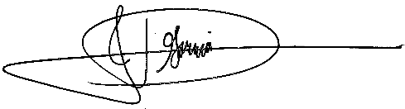  Member
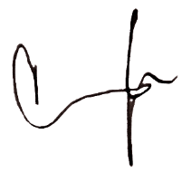  ESTRELLES, CARREN NICOLE A. | GARCIA, JOHN DAVID R.
  Member | Member
RULLODA, JADE ALLYSA A.
Member

Approved:

EMELY A. MUNAR, DIT (c)
Thesis Adviser

Don Mariano Marcos State University
South La Union Campus
COLLEGE OF COMPUTER SCIENCE
Agoo, La Union

June 29, 2026

NAME OF FACULTY
Faculty Member, College of Computer Science
DMMMSU – SLUC
Agoo, La Union

Sir/Madam:

We, the undersigned BS Computer Science students are enrolled in the subject Thesis Writing. One of the requirements of the course is for us to undergo the process of research and be able to create a project that will beneficial to the university.

In connection to this, we would like to ask for your support to be our Thesis Panel Member for our study entitled “Design and Implementation of a Real-Time LAN-Based Queuing Management and Statistical Reporting System for the Business Permits, Licensing - Local Investment and Enterprise Office (BPL-LIEO) of LGU Rosario, La Union”.

We hope that this request will merit your approval. We will highly appreciate your considerations to this regard.

Thank you very much and more power.

Very truly yours,

TANDAS, ROJEAN F. | BARBOSA, MANRIJAN M.
Leader | Member
ESTRELLES, CARREN NICOLE A. | GARCIA, JOHN DAVID R.
Member | Member
RULLODA, JADE ALLYSA A.
Member

Approved:

NAME OF FACULTY
Thesis Panel Member

